CHURCH OF SOUTH INDIA
DEPARTMENT OF CHRISTIAN EDUCATION
Report of the programs conducted by the Department of Christian Education from August 2017 to April, 2018
1.Trainers of Trainees (ToTs) for Missional Congregations, 22nd to 24th November, 2017
A three days’ training program named, Trainers of Trainees (ToTs) for Missional Congregations was held for the Christian educators and Sunday school teachers from 22nd to 24th November 2017 at the synod centre, Chennai in which 76 committed Christian educators from 19 dioceses participated.
In his inaugural devotion, Rev. Dr. Ratnakara Sadananda, the General Secretary of CSI appreciated the role of Sunday school teachers in leading the largest lay movement in the church voluntarily and passionately, which marks the continuity of Christian faith in our churches. Rt. Rev. Dr. B.D. Prasada Ra, in his key note address reaffirmed the role of Christian education in the mission and ministry of Church of South India. Rev. Dr. Krupa Victor led a session on the historical overview of Christian education and its impact on the ministry of Sunday schools in CSI. Rev. Dr. Arun Gopal. While speaking on the theme, ‘educational psychology and ministry to children’ reminded the participants to understand every child in order to meet out to the differing needs of them with Christian values. Special sessions on introducing themes such as human sexuality and ecological sensitivity to Sunday schools were led by Rev. Dr. Jayachitra L and Dr. Mathew Koshy Punnackad respectively. Creative ways of communicating gospel through various means such as puppets were also introduced. The training program was concluded with challenging the participants to carry forward the mission to children by enhancing child friendly churches and Sunday schools all over Church of South India.
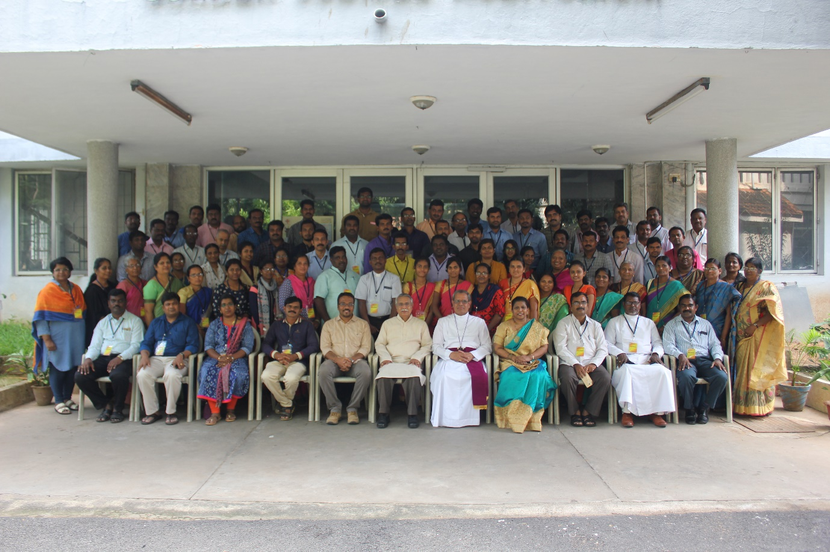

2. Peter Cater Scripture Knowledge Exam Prize Distribution
The rank holders of Peter Cater Scripture Knowledge exam for the years 2016 and 2017 were felicitated with cash awards on 13th January, 2018. 48 children with their parents/care takers attended a half-day retreat on the theme “Nurturing Children in Faith” at CSI synod centre.

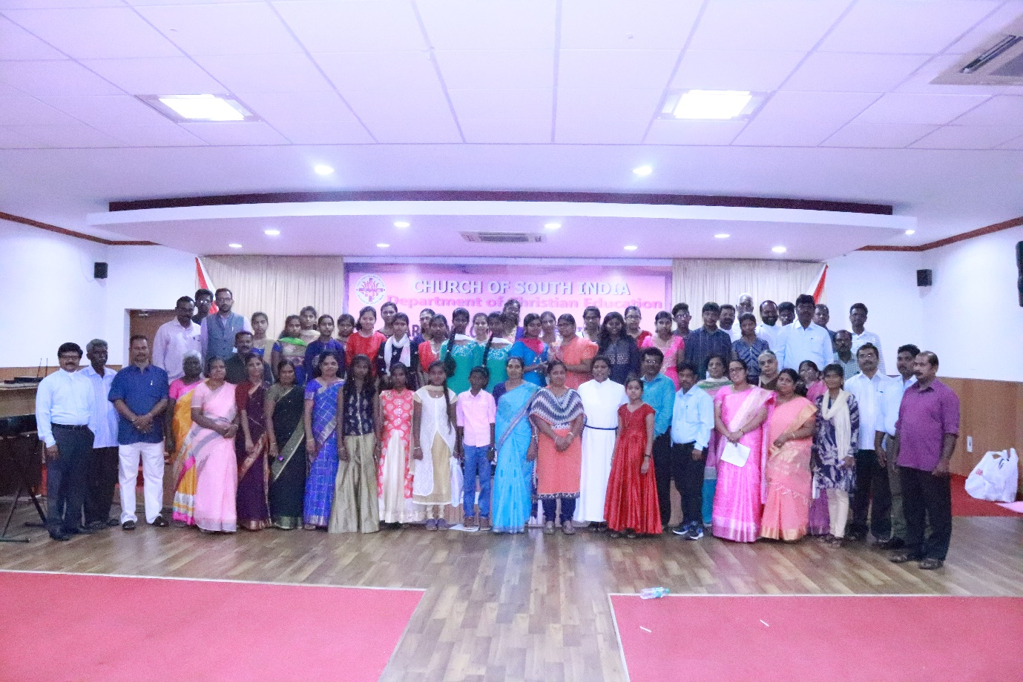

3. Peter Cater Scripture Knowledge Exam
The Peter Cater exam for the year 2018 was held on 20th January, 2018.
About 700 children studying in class IX and XI from seven dioceses participated in the Peter Cater Scripture Knowledge exam held on 20th January, 2018 at seven exam centres.
4. Developing CSI Child Protection Policy with Children from Three Regions of CSI
The department of Christian education along with Girl Child Campaign Program of CSI-Seva conducted three two-days meetings with Sunday school children from Tamil, Malayalam and Kannada regions on 13th -14th January, 2018, 26th-27th January, 2018 and 10th -11th February, 2018 at Chennai, Shoranur and Bangalore respectively. These meetings were conducted to incorporate the view points and aspirations of children into the proposed CSI child policy.
5. Training of Sunday School Teachers of the Diocese of Kollam-Kottarakara on 13th February, 2018
About 240 Sunday school teachers gathered for a training program that focused on the development of teaching skills and Bible lesson preparation and presentation.
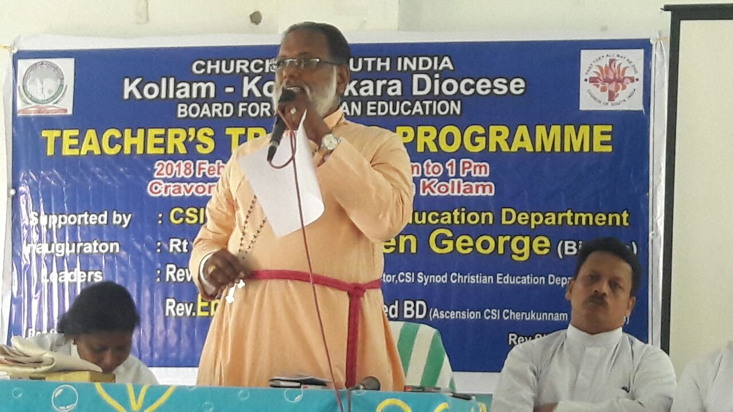

6. Malayalam Regional training program at Melukaavumattom from 27th -28th February, 2018
A two-days’ regional training program will be conducted on 27th-28th February, 2018 at HRDT Centre, Malukaavumattom to train about 60 Sunday school teachers from the Malayalam region on Bible lesson planning, preparation and presentation.

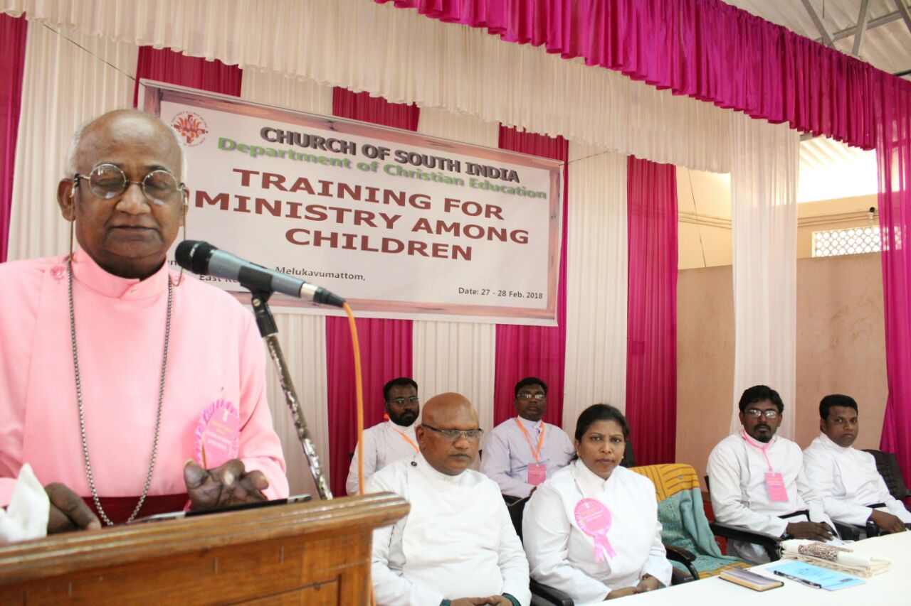

7. Core Committee Meeting for the curriculum of “Wings of Faith”
A group experts on Sunday school curriculum met on 7th march at CSI synod centre to discuss about bringing out resource material for Sunday schools in all the dioceses.

8. Training of Sunday School Teachers for children-friendly Churches at Karim Nagar, Karim Nagar Diocese, 10th March, 2018
one-day training program for Sunday school teachers of Karim Nagar Diocese, Telengana was conducted at Centenary Wesley Church, Karimnagar on 11th March, 2018. 127 teachers from four regions such as Warangal, karimnagar, Jagtial and Parkal attended this training program that intended to help them to develop children-friendly Sunday schools and churches. Sessions were held on "biblical methods of counselling children", and "counselling different age groups of children".

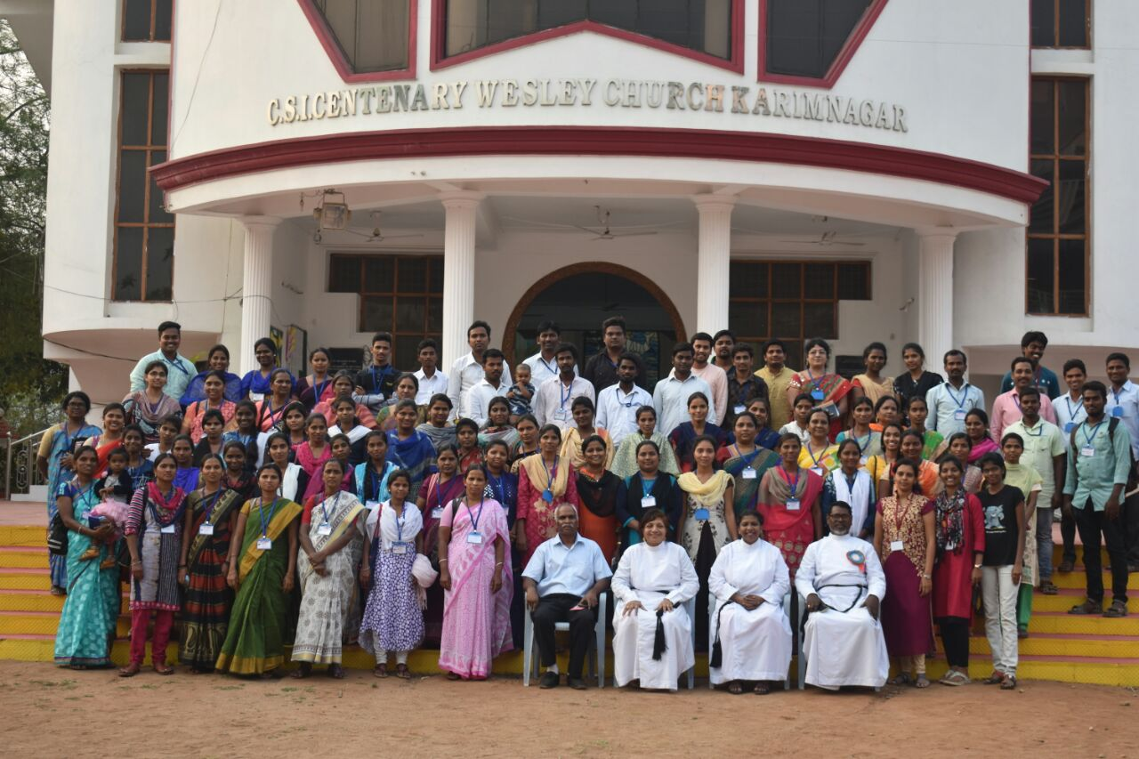

9. Training of Sunday School Teachers for children-friendly Churches at Nandyal, Nandyal Diocese, 6th April, 2018
One-day training program for Sunday School teachers of Nandyal Diocese was held at Bishop’s Chapel at Nandyal on 6th April, 2018. 123 participants benefitted from the sessions on Children-friendly Sunday schools and churches that focused on counselling skills for different age-groups.

