IXWORTH – TOILET TWINNED VILLAGE
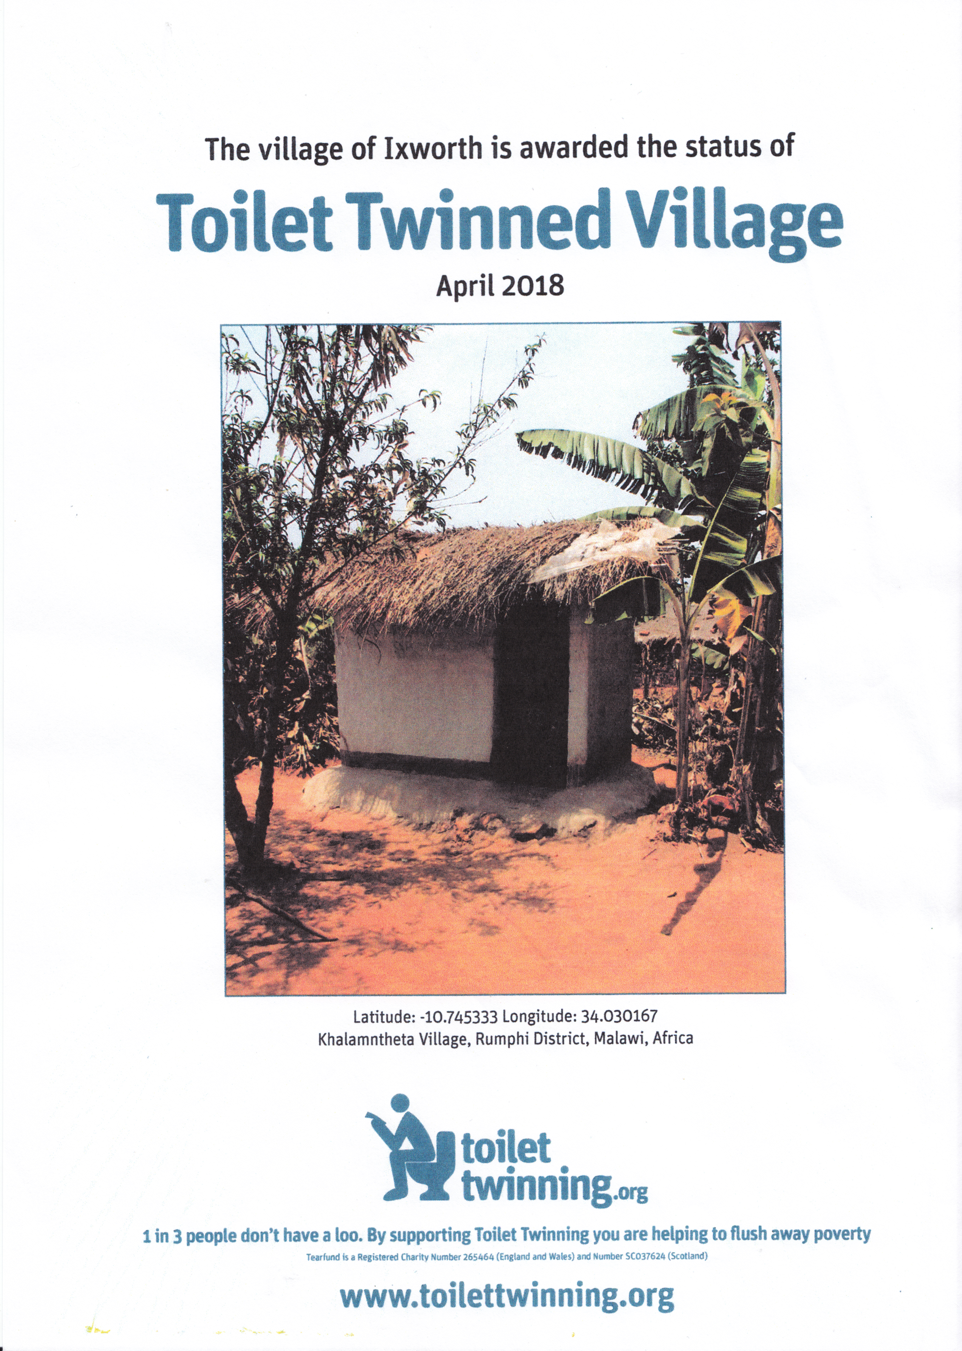Thanks to the tremendous support from Ixworth Village over the last 4 years £1380 has been raised for the Toilet Twinning Charity. 18 individual toilets and toilet blocks in Ixworth and surrounding villages are now twinned with toilets in countries across the world, where people didn’t have proper sanitation before. As a result Ixworth now has the privilege of being a ‘Toilet Twinned Village’ and we are twinned with Khalamntheta Village in Malawi.
It is so important to health, education and general well-being to have proper sanitation that we wanted to continue supporting the Toilet Twinning charity at this year’s Christmas Tree Festival at Ixworth Methodist Church.
However we are very conscious that there are many in need on our own doorstep, so the other half of the proceeds from the Festival has been sent to Bury Drop In to support homeless and vulnerable people in Bury St Edmunds.

