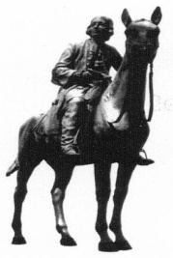
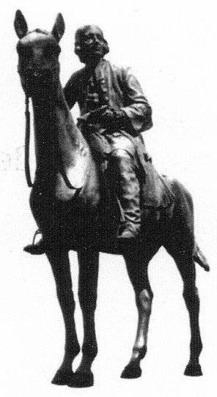
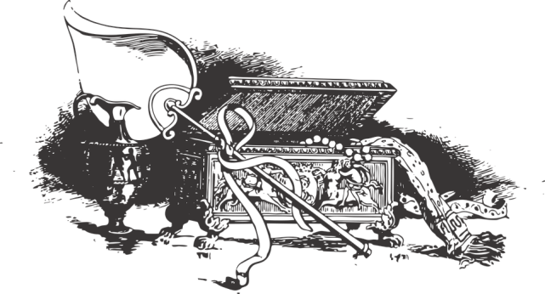

A talk by

Liaison Officer for Methodist Historic Objects
on Saturday 7th May at 3 pm
at Acle Methodist Church
Non members very welcome
Afternoon tea following the talk
Please book for this on 01603 423535
or email – ursula.franklin19@gmail.com

