**FREDDY AND DEE Takavarasha QUATERLEY NEWSLETTER**

**JANUARY TO MARCH 2018**

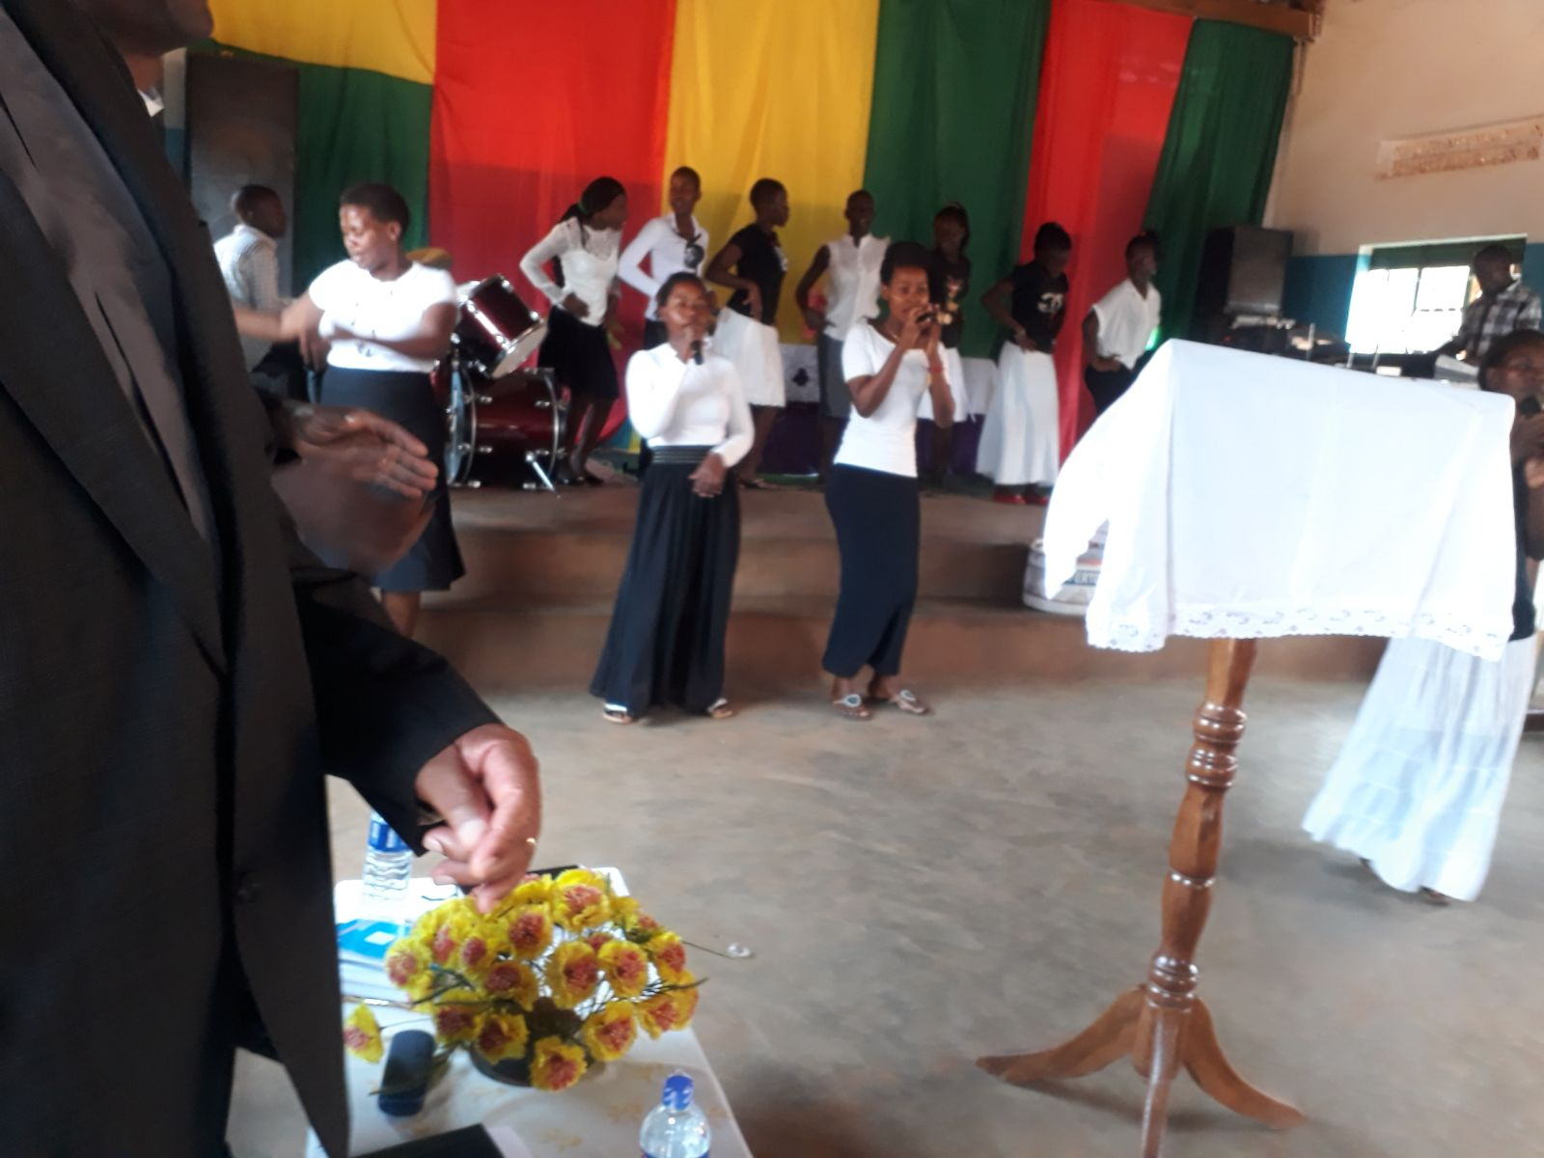

**Dear Friends,**

**Greetings from The Methodist Church in Uganda**

**“All hail the Lamb, enthroned on high;**

**His praise shall be our battle cry;**

**He reigns victorious, forever glorious;**

**His name is Jesus, He is the Lord”**

**So writes songwriter Dave Bilbrough as far back as 1987, yet it still resonates with us and our Ministry in Uganda. Yes, there are enough challenges to keep us soldiering on, and enough exciting moments to raise our hopes of a brighter future!**

**We arrived safely on 4 January at 8pm to a rousing welcome by the Bishop and the Synod Leadership. We shared a meal prepared in our honor, shown around the Manse, and whisked away to a local hotel as the Manse was still without electricity. The next day we decided to move into the Manse as is, unpacking around the workmen still tidying up loose ends, painting, connecting electricity, fitting doors and cupboards, sorting out plumbing and fixing taps and generally making final touches to make the Manse habitable. Exciting times indeed!**

**So much has happened since. We quickly settled in and as soon as a suitable vehicle was sourced and bought, we embarked on a 10 day tour of the Circuits, the major objective being familiarization. As most of Methodist Church in Uganda Churches (MCU) are in the rural areas, we took advantage of this trip to include meetings with Junior Church and Youth Leadership to assess the needs (Dee and Youth Coordinator) and training Stewards, Pastors and Treasurers on Stewardship (Freddy and MCU Accountant).**

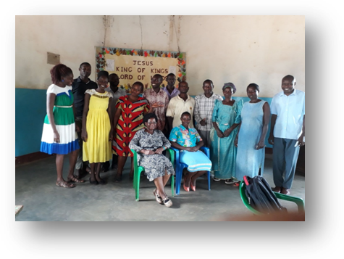

**The one thing we observed with the fresh eyes of newcomers was the poverty, deprivation and associated social problems such as teenage pregnancies and early marriages. Evident also was lack of resources, (A single bible, if at all, in whole congregations) illiteracy, lack of shelters, (A Church could be a simple banana leaf and grass shack)**



**The need is so great in all the rural areas we visited on this trip that we felt overwhelmed.**

**This trip also proved useful in that I got to meet with the Ministers in their respective Circuits. The trip was also an eye opener in terms of the operations of this young church. To help you understand Methodist Church in Uganda, the setup is that it comprises six Circuits, each with a Minister, who works with Lay Pastors. Each Minister has an average of 7 Churches and each Church has a local lay Pastor. My conversation with the Ministers was therefore quite enlightening.**

**The Ministers are currently on 50% stipend, now verified, which amounts to £93 a month, and those that are not housed in Manses pay monthly rent of approximately £40, yet somehow, until recently when a donation of 4 motor cycles was received, they had to visit their churches by public transport with no financial help from the Church. Even now, they need to fuel and service the motor cycles from own resources. Not surprising that one or two of them seem demotivated.**

**Dee’s role as Junior Church Coordinator involves School Assemblies, training of leadership throughout the Circuits and planning and preparing teaching materials for Junior Church ministry. Coordinating the activities of Junior Church is a challenging but exciting and rewarding exercise which takes up a lot of frustrating time due to lack of resources and the obvious communication obstacles of language and distance.**

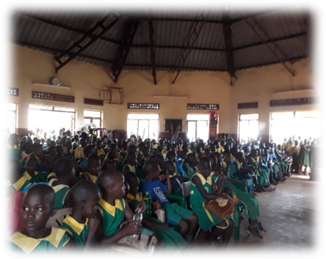

**While Dee is engrossed in that, I am busy with my role whose exciting title is Mission Enabler, which probably means dogsbody in Mission. Whichever way you look at it, it remains an exciting role! However, it has its formal aspects as well, and that is being the Minister of the largest Church, and having training responsibilities at all levels.**

**Highlights of this quarter include the arrival of 50 Sunday School Teachers from Kenya for Easter. Accompanying them was a group of 35 enthusiastic Youth and their Ministers. This was an invigorating weekend of fellowship and teaching, culminating in vibrant worship each evening. While this was a blessing in every way, it also highlighted what the Church in Uganda still lacks in terms of organization and resources, but it is not for lack of effort, rather a lot of training still needs to be done.**

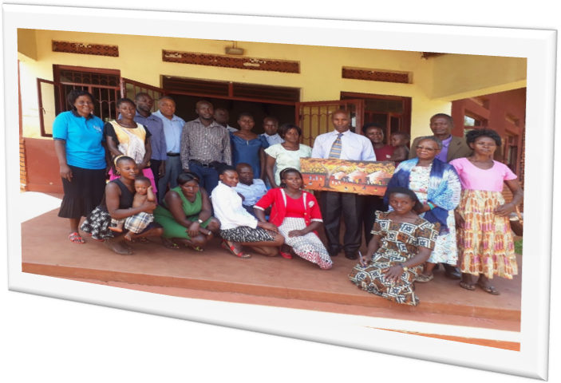

**PLEASE PRAY FOR;**

**Our continued good health**

**Our continued adjustment to a new culture and new environment**

**Our Ministry, which seems to change shape month by month.**

**The Church, its Ministry, its leadership, both Lay and ordained**

**The 5 year Strategic plan the Church embarked on two years ago.**

**We are contactable on the following email addresses and mobile phone numbers;**

[**takavarashafyz@btinternet.com**](mailto:takavarashafyz@btinternet.com)

**+ 256 777 031111 (Freddy)**

[**deetakavarasha@gmail.com**](mailto:deetakavarasha@gmail.com)

**+ 256 777 681555 (Dee)**