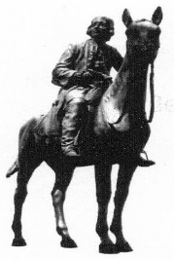
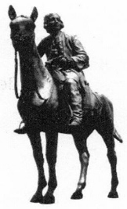
Wesley Historical Society
The life and work of
Susanna Wesley
A talk by Ursula Franklin
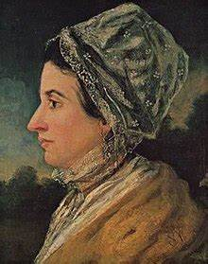
Saturday 5th October at 3 pm
at
Hungate Methodist/URC Church
Beccles
Non members very welcome
Refreshments following the talk

