Open Garden invitation from Jackie and Briant Smith.
Helyg, Thetford Road, Coney Weston, IP31 1DN
Looking out of the window on a dark, dank January day did not entice me outside, but when I did go to the woodland walk I found our beautiful little Iris unguicularis in full bloom. It lifted my spirits! Then I saw all the bulbs popping up and started looking forward to a really good show for our NGS Open Day on 19th April.
Are you thinking of a venue for your group outing, or quiet day, this year? You may like to come to visit our garden, looking for hidden treasures and enjoying a time of relaxation and contemplation in the peace of the Suffolk/Norfolk border countryside.
You can also enjoy a cream tea served on the patio or in the conservatory all included in the cost.
Set in just under half an acre the garden is always evolving to provide many quiet seating areas set amidst some stunning planting, wildlife areas which attract birds and other wildlife, and innovative settings for growing flowers and vegetables.
We are open by arrangement from May to October, have good parking facilities and are located centrally in the District.
The garden is open under the National Gardens Scheme at other times.
Money raised for Mental Health charities
Further details from 01359 220106
jackie.ks@hotmail.co.uk
briant.broadsspirituality@gmail.com
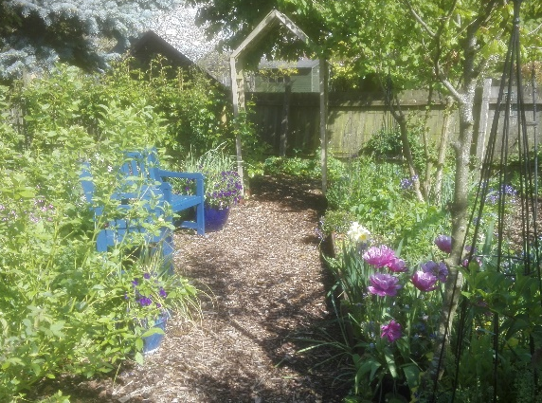
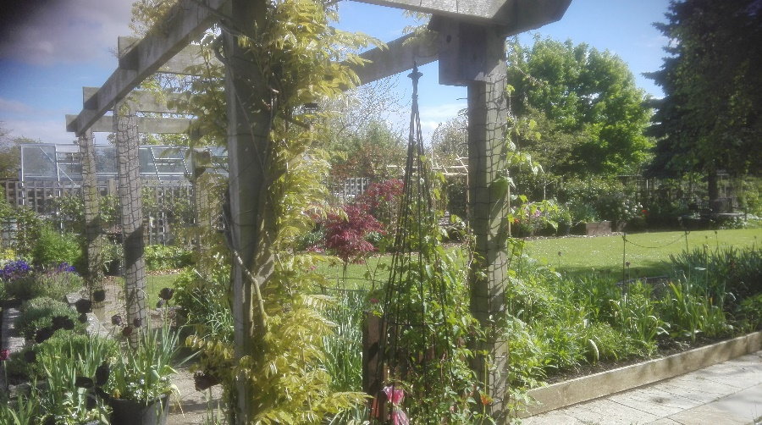
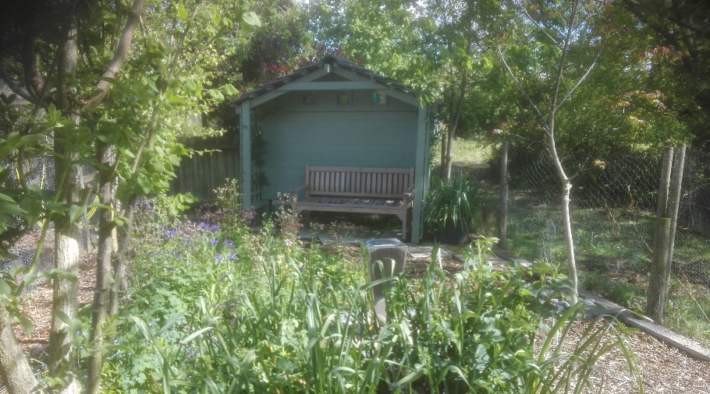

Open Garden invitation from Jackie and Briant Smith.
Helyg, Thetford Road, Coney Weston, IP31 1DN
Looking out of the window on a dark, dank January day did not entice me outside, but when I did go to the woodland walk I found our beautiful little Iris unguicularis in full bloom. It lifted my spirits! Then I saw all the bulbs popping up and started looking forward to a really good show for our NGS Open Day on 19th April.
Are you thinking of a venue for your group outing, or quiet day, this year? You may like to come to visit our garden, looking for hidden treasures and enjoying a time of relaxation and contemplation in the peace of the Suffolk/Norfolk border countryside.
You can also enjoy a cream tea served on the patio or in the conservatory all included in the cost.
Set in just under half an acre the garden is always evolving to provide many quiet seating areas set amidst some stunning planting, wildlife areas which attract birds and other wildlife, and innovative settings for growing flowers and vegetables.
We are open by arrangement from May to October, have good parking facilities and are located centrally in the District.
The garden is open under the National Gardens Scheme at other times.
Money raised for Mental Health charities
Further details from 01359 220106
jackie.ks@hotmail.co.uk
briant.broadsspirituality@gmail.com

