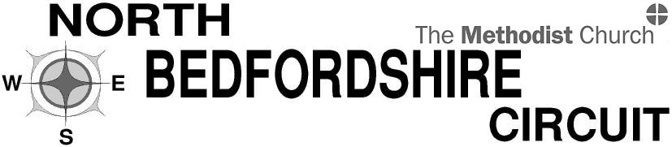
Charity number 1129523

North Bedfordshire Methodist Circuit

is seeking a

Circuit Safeguarding Officer

to promote safeguarding and to ensure compliance, providing advice and support as required

Up to 40 hours per month, to be worked flexibly with some weekend and evening work
at £13.50 per hour

Detailed knowledge of Safeguarding issues and procedures and experience of working in Safeguarding is essential. Appointment is subject to a satisfactory DBS check

The application pack can be obtained from
Mrs Stephanie Field at the Circuit Office
Email northbedscircuitoffice@gmail.com
Phone 07522 928936

Closing date for applications: Wednesday 7th October 2020 Interviews will be held w/c 19th October 2020

