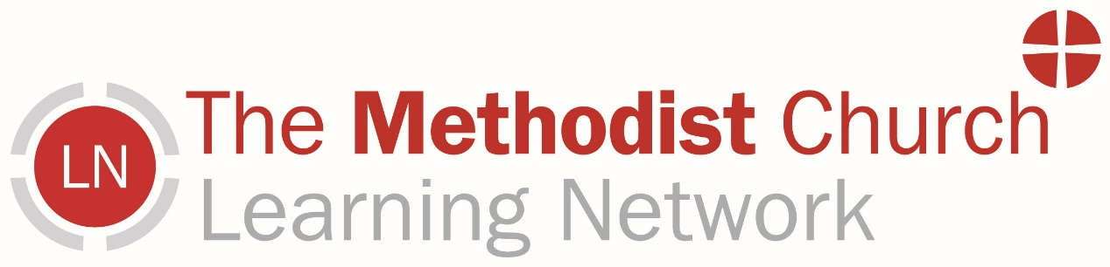

Learning Network Report
East Anglia
The Learning Network exists to support, encourage, and inspire Methodist people in all aspects of Our Calling. Together, we strive to be a church that is inclusive, justice-seeking, evangelistic, and growing.
What we have been up to:
We have both been busy organising and delivering training and development opportunities around the District, alongside our Connexional Work. These have included:
- Multiple Advanced Safeguarding Training opportunities.
- ‘Working out Worship’ (Training for worship leaders and those leading local arrangements).
- Working with the District Eco-Champion, Lesley, to create a comprehensive District resource for a ‘World Environment Day’ service on the 7th June.
- ‘Train-the-trainer’ session for Foundation Safeguarding Training (To increase the number of those around the District who can deliver the Foundation Safeguarding Training)
- Working with the District Local Preacher Secretary, Celia, to start developing Worship Leader and Local Preacher celebration events.
- Church Vision Days
Planned events coming up:
- Local Preacher and Worship Leader celebration events around the District in July
- Train the Trainer (EDI) Session – 9th June
- ‘Working Out Worship’ Events
- Vision Days at Churches in the District
- Circuit Mission Days in the District
- Circuit Stewards Stationing Training (Visits and Profiles)
If your Church/Circuit is interested in any training or development opportunities, please don’t hesitate to get in touch!

How the Learning Network Works
The Learning Network (LN) primarily works with both lay and ordained church leaders, helping you develop your skills so you, in turn, can equip others.
The LN collaborates with other colleagues in the Connexional Team, as well as many of those in District and Circuits leadership roles, and, at times, with local churches to equip and resource church communities.
Each Learning & Development Officer (LDO) is aligned with a specific Methodist District, and Jenna and Seb are both part-time and co-aligned to the East Anglia District. Support we can offer includes:
- Accompanying lay and ordained church leaders, supporting their growth and ministry.
- Enabling church, circuit and district leaders to access lifelong learning opportunities
- Facilitate growth and mission planning for the district and circuit.
Alongside District-based work, we also contribute to wider Connexional learning and development opportunities.
We’d love for as many people as possible to know of our work, and therefore there are different ways to remain connected with us. Hopefully one of these will work for you;
Newsletter; this comes out monthly, direct to your inbox. Sign Up for Newsletters - The Methodist Church
Facebook; There is a closed group, currently with 1500 members, where you can join for conversation about learning and development in the Methodist church, and to hear first about upcoming opportunities. https://www.facebook.com/groups/thelearningnetwork/
Eventbrite; Join over 1000 people and receive emails from time to time promoting new Learning and Development opportunities. Methodist Learning Network Events - 36 Upcoming Activities and Tickets | Eventbrite
(Courses and events we offer include: Circuit Stewards Training, Lay Orientation Training, Reflective Line Management, The Discernment Course, Bible Month, Encounter, Explore, Equality Diversity and Inclusion Support, Worship Leading and Preaching Development, Caring and Wellbeing (including Who Cares? and The Last Taboo), Supporting Rural Ministry and Mission, Supervision Training, Ministerial Wellbeing, and Positive Working Together)
Methodist Church Website; There are many learning and development opportunities within the church, some we lead and some by other colleagues. Direct link to the Learning Network pages.
Many blessings,
Jenna and Seb



Jenna Thorne Seb Bell
Learning and Development Officer Learning and Development Officer
thornej@methodistchurch.org.uk bells@methodistchurch.org.uk
07984 638360 07425 992937

